Sri Lanka Institute of Information Technology

IT2050 - Computer Networks 2nd Year, 1st Semester

Tutorial 1

- ABC Company just purchased three new routers to start their company network. Which items are needed to establish a terminal session between a PC and the router for the initial configuration?

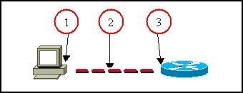

- RS 232 Port
- Console cable
- Console port

- State the methods to log to a router.
    - Console
    - Auxiliary (AUX)
    - Telnet

- Explain the main modes found in the process of configuring the router.
    - User EXEC Mode
    - Privileged EXEC Mode
    - Global Configuration Mode

- State the two ways to retrieve previously used commands.
    - “show history” command [Privileged Mode] , “do show history” command [Global Configuration Mode]
    - Use up and down arrow keys

- How do you configure passwords for privilege mode?
    - enable password <PASSWORD>
    - enable secret <PASSWORD>
Which password takes precedence?
Secret password takes the precedence.

- What are the functions of the RAM?
    - Stores running / current configuration file.
    - Acts as a working storage.

- Which keystrokes can be used to return to the privileged mode from the interface configuration mode?
    - Ctrl + Z
    - Type “exit” two times.

- Which router component holds the configuration file when power is lost?
    - NVRAM

- How do you view the current configuration of the router?
    - “show running-config” [ In Privileged Mode]

- State the method of making a permanent copy of the configurations.
    - “copy running-config startup-config” [In Privileged Mode]

1

